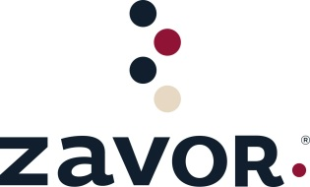

**Independents FREIGHT ALLOWANCES 2023**

From January 1st to June 30th, 2023

|  |  |  |
| --- | --- | --- |
| **Purchase Order Value** |  | **Freight Allowance** |
|  |  |  |
| Orders from $ 500 to $999.99 |  | $50 |
| Orders from $ 1000 to $ 1499.99 |  | $100 |
| Orders from $1,500 to $ 2,499.99 |  | $150 |
| Orders over $ 2,500 |  | $ 200 |
|  |  |  |

**Freight allowance will be applied upon receipt and entry of the PO and it will be reflected on the invoice.**

Out-of-stock items will not qualify for promotional prices or freight allowances. The promotional ranges include only the value of the invoiced product and not the freight charge.

The deduction for the Freight Allowance cannot exceed the actual value of the freight charge.

** Promotion is valid for orders shipping to Independent retailers from 3PL Worldwide’s location in Southington, CT **